Task Description#1 (Classes)
• Use AI to complete a Student class with attributes and a method.
• Check output
• Analyze the code generated by AI tool
Expected Output#1
• Class with constructor and display_details() method
Prompt: complete a Student class with attributes and a method.
CODE:
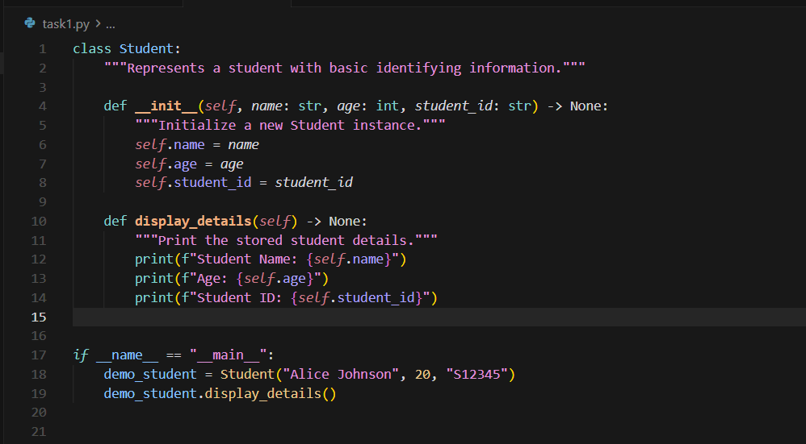
OUTPUT:
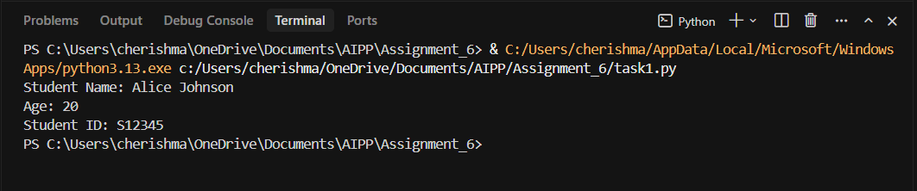
Task Description#2 (Loops)
• Prompt AI to complete a function that prints the first 10 multiples of a number using a
loop.
• Analyze the generated code
• Ask AI to generate code using other controlled looping
Expected Output#2
• Correct loop-based implementation
Prompt: complete a function that prints the first 10 multiples of a number using a
loop.
CODE:
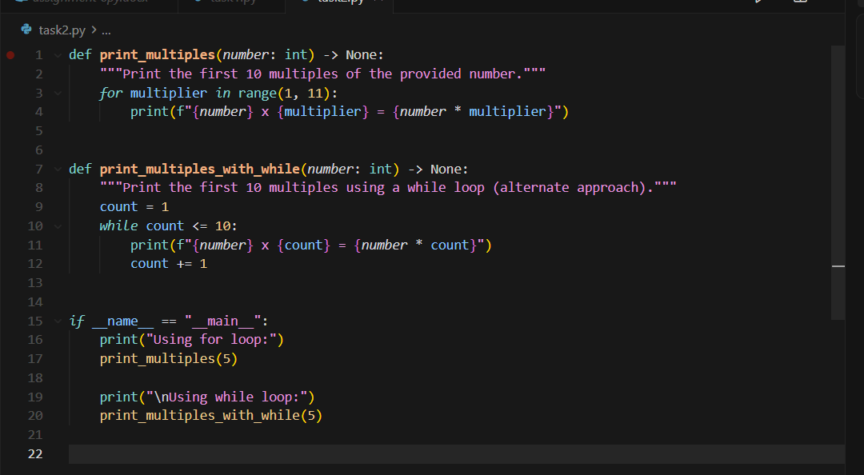
OUTPUT:
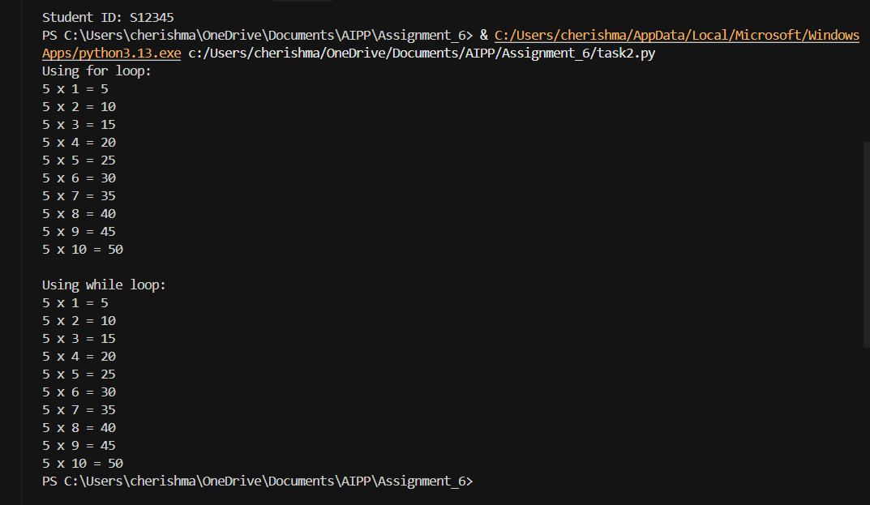
Task Description#3 (Conditional Statements)
• Ask AI to write nested if-elif-else conditionals to classify age groups.
• Analyze the generated code
• Ask AI to generate code using other conditional statements
Expected Output#3
• Age classification function with appropriate conditions and with explanation
Prompt: generate code using other conditional statements
CODE:
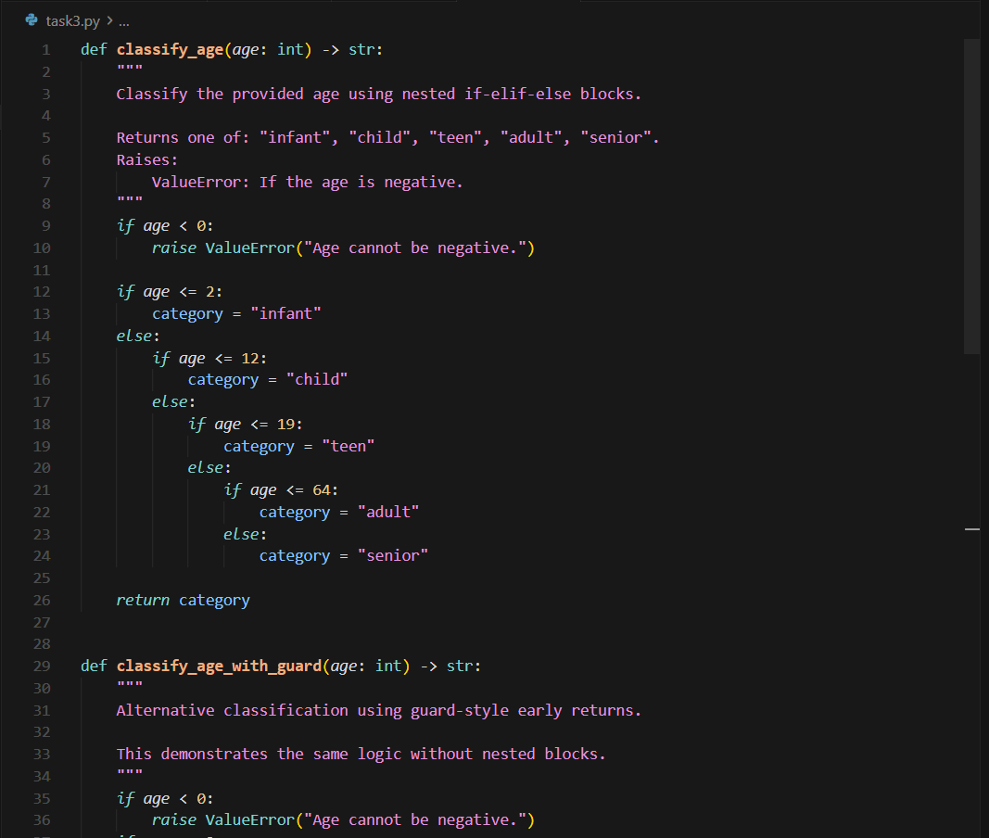
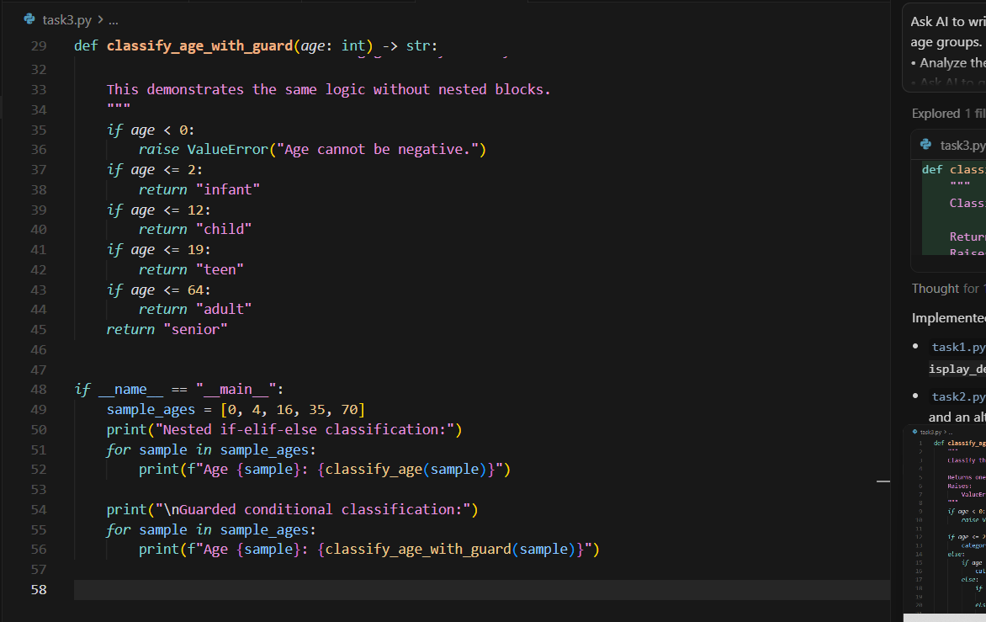
OUTPUT:
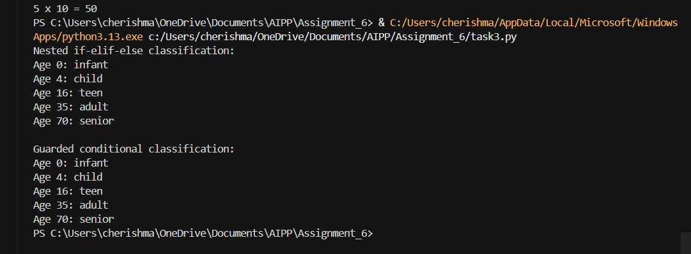
Task Description#4 (For and While loops)
• Generate a sum_to_n() function to calculate sum of first n numbers
• Analyze the generated code
• Get suggestions from AI with other controlled looping
Expected Output#4
• Python code with explanation
Prompt: Generate a sum_to_n() function to calculate sum of first n numbers
CODE:
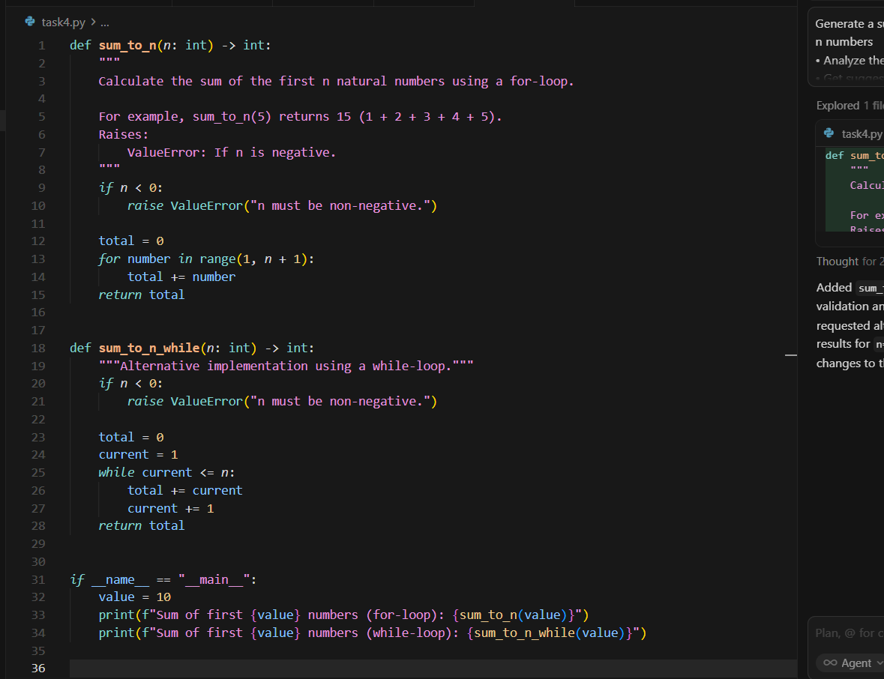
OUTPUT:
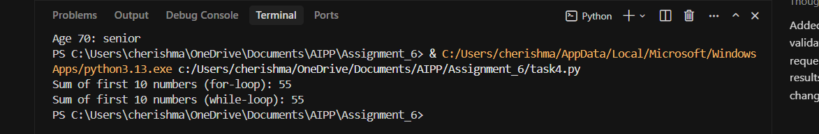
Task Description#5 (Class)
• Use AI to build a BankAccount class with deposit, withdraw, and balance methods.
• Analyze the generated code
• Add comments and explain code
Expected Output#5
• Python code with explanation
Prompt: to build a BankAccount class with deposit, withdraw, and balance methods.
CODE:
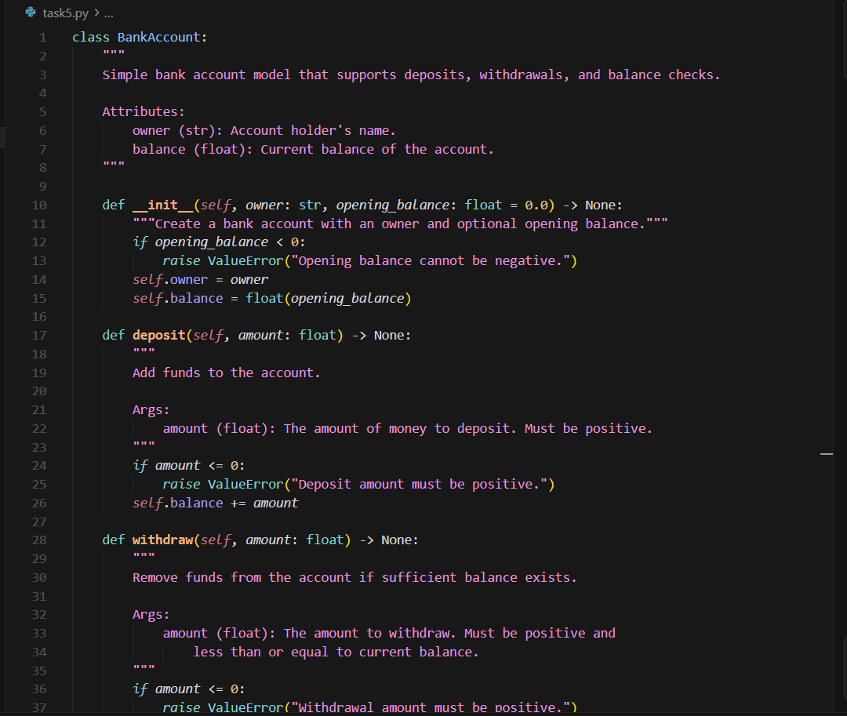
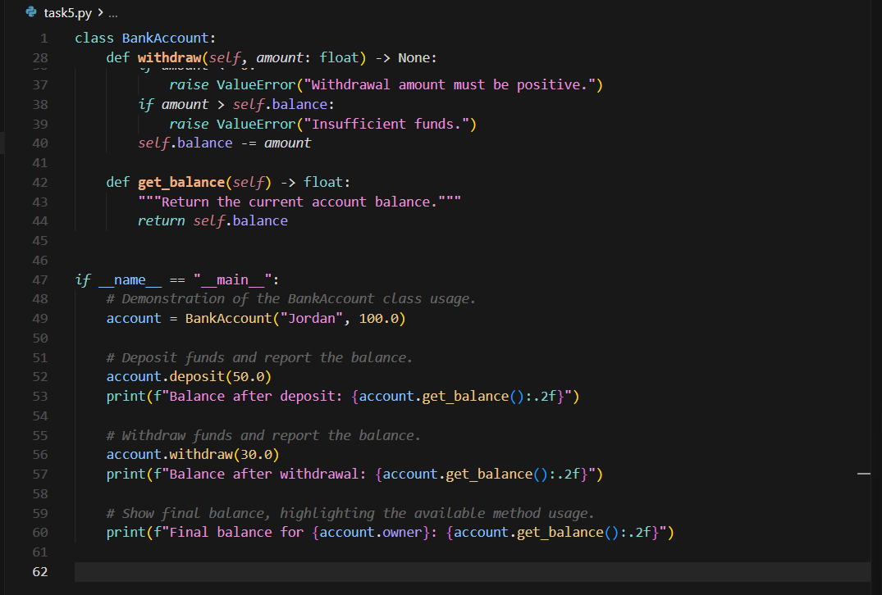
OUTPUT:
